
LjunggrenAudio RYO Altered States
Dual State Variable Voltage Controlled Filter

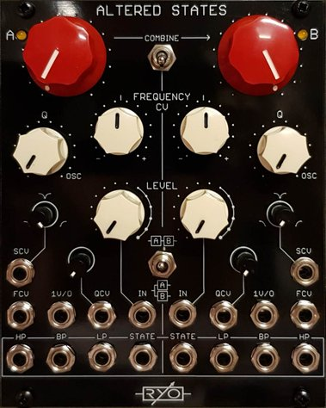

- dual analogue state variable filter.
- based on 2164 Quad VCA chipset 12db/Oct filter cores.
- full voltage control over cutoff frequency and resonance.
- individual outputs for each filter response.
- variable state output with manual and voltage control.
- All analogue circuitry.
- hi-fidelity signal chain with low noise opamps and VCAs.
- Buffered inputs and outputs.
- toggle switches for Combine (links the filter B frequency cutoff controls to filter A) and serial or parallel input routing.
- compact 45mm Depth (with power cable attached).
- low power draw: 112mA +12V / 106mA -12V / 0mA +5V.
- Works for audio as well as CV.
- Fast responding CV inputs accept both DC signals and AC signals into the full audio range.
- cores are very stable and will give you around 5 octaves of 1V/O tracking sine wave self-oscillation.
- LP, BP and HP outputs each have a different phased sine.

downloads
* user manual
* quickstart guide
* assembly guide
* hi-res schematic
* datasheet
* BOM

